**Business Requirements Document**

**Project: eVal Implementation**

**BRD Title: Scoring & Rating**

**BRD: #2**

**Development required by:**

***Washington State’s eVal Team***

**BACKGROUND**

This Business Requirement Document (BRD) is part of a set of business requirement documents that are part of the Seattle School District’s 2015 implementation of Washington State’s online evaluation tool, eVal. eVal is an online tool developed by the State to support teacher professional growth in alignment with Washington State’s mandates for TPEP (Teacher Principal Evaluation Process). The project goal is to successfully integrate this tool into the District’s TPEP activities, adhering to the District’s obligations of its CBA and to the spirit of the TPEP process which is aimed at fostering professional growth through collaborative, face-to-face discussions between teacher and evaluator.

BRDs related to eVal functionality have been submitted to the State’s eVal development team. BRDs related to back-office activities which require District development have been submitted to DOTs (the District’s development team). Where noted, several of these documents require review and collaboration from both teams.

*For further information, please see Excel file “eVal Seattle - Enhancements and BRD Index” which contains listing of each enhancement that has been approved for development and the related BRD and assigned development team.*

|  |  |  | Description of Change |
| --- | --- | --- | --- |
| 1 | 10/31/14 | Donna Schmidt | Baseline; submitted to for review to eVal, DOTs and HR teams |
| 2 | 11/14/14 | Donna Schmidt | Added requirements 2.3 and 2.9 per discussion with SEA and eVal teams regarding District’s approach to preponderance of evidence. |
| 3 | 11/19/14 | Donna Schmidt | Misc. word smithing per stakeholder review (no material changes); updated Review/Approval table to reflect current status |

# High Level Requirement Description

The requirements in this document relate to changes requested to the eVal tool so that scoring and rating activities align with the spirit and/or language of the District’s CBA

# Business Objective

Evaluators can use eVal to observe teachers and provide a final evaluation in alignment with the District CBA and the manner in which the District has implemented TPEP

# Business processes impacted by the change

Any part of the TPEP process supported by the eVal tool in which the evaluator may select a rating or score

# Requirement Details

| ID | Requirement | Purpose or expected outcome |
| --- | --- | --- |
| 2.1 | Related to the **observation process**, remove inference of rating at the component level, domain level or overall observation level. This applies for all places in the current UI where now the user would be able to provide a score as part of the observation process (i.e., any checkbox that would allow the user to denote an actual score should be removed; any area where it looks like one “should have” entered a score at component or observation level should be removed). These changes should apply equally to the teacher and the evaluator online experience. | Observation sessions cannot be rated in any way that would generate a score towards the final summative state rubric score. Also, the District does not score at the domain or component level during observations.  Therefore, Raw Score on the Observation panel, Observation Summative Score checkboxes, Observation Criteria checkboxes, and Observation rubric element checkboxes should be removed or hidden from view. (This list may not be exhaustive; the eVal team will know best all the areas where a user might be prompted to enter a score) |
| 2.2 | **Observation reports** should not contain any inference that scoring at the domain, component or overall observation level is possible. Report settings should not include option to include any observation scores. | The District is concerned that if column headings or empty boxes appear on the report where Observation ratings would otherwise appear, it gives the inference that it is possible to rate at the domain or component level or provide a rating for the observation overall. Also, the appearance of empty boxes gives the inference, in general, that important information was left out and that these boxes should have been filled.  Therefore, Print Preview, PDF Print, and paper printed copies should not contain any visibility of where component scores, domain scores or overall observation scores could have been entered/populated in the rubric view. Specifically, there should be no columns, and no empty boxes on the reports or other areas on the report, that infer that rating an observation is possible. |
| 2.3 | When a user selects “Highlight and add to evidence”, they should immediately receive a prompt to enter the evidence that supports this **claim statement,** and the text box for entering that evidence should be opened and accessible to them. | (This requirement came out of the “preponderance of evidence” discussion with SEA, Seattle and the eVal team in which SEA asked for ability to ensure that evaluators were prompted to support claim statements with evidence.) |
| 2.4 | Need to ensure that a user selection of **claim statements** would not visibly be associated with a rating or score for any observation either within the UI or on any printed report | In order to prevent any inference that the evaluator is rating at the observation level, the District requests that the functional option of ‘Highlight and Add to Evidence’ will not in the future include the corresponding context of its ratings and scores. (e.g. 1-Unsatisfactory, 2-Basic, 3-Proficient, 4-Distinguished)  Note: This requirement is included because it is understood that Edmonds School District has requested that the context to the claim statement (i.e., “1-Unsat”) be included on reports. The District wants to make sure that should the Edmonds feature be implemented, it will not affect the District’s settings. |
| 2.5 | Related to **summative** **evaluation scoring**: Remove inference of rating at the component level anywhere in the UI where, currently, the user would be able to provide a score at the component level (i.e., any checkbox that would allow the user to denote an actual score at the component level should be removed) | Evaluator should not have the option to checkmark/score at the component-level.  Exception:  The evaluator will need the ability to score Student Growth components. |
| 2.6 | **Evaluation reports** should not contain any inference that scoring at the component level is possible. Report settings should not include option to include component scores. | Print Preview, PDF Print, and paper printed copies will not contain any visibility of areas where, otherwise, component scoring would have appeared. (No columns; no empty check boxes) |
| 2.7 | Disable any scoring ability for Non- Student Growth components when entering evaluation scores | Related to items 4.1 and 4.3 above. In the current tool, when the user expands a State Critiera in order to rate a Student Growth component, the non-Student Growth components are also available. This requirement is to make sure that when rating the Student Growth components, the evaluator cannot also inadvertently rate a non-Student Growth component for that Criteria. |
| 2.8 | Highlight on the UI where the evaluators should go to rate Student Growth components | [This is a nice-to-have and can be dropped if not aligned with eVal’s UI strategy]  Though highlighting, or color, or message, it would be ideal if it were a little easier for a new user to understand where they need to click in order to score Student Growth. This may become especially important after all other scoring at component level is disabled, as the evaluators will only be scoring at the component level for the Student Growth components. |
| 2.9 | When scoring the teacher as part of the summative evaluation process, instead of seeing a UI panel for component/observation scores, the evaluator should have easy access to data collected throughout the year *grouped by State Criteria.* Additionally, this information should be flagged in a manner that allows the evaluator to quickly differentiate the data gathered later in the year from the data gathered earlier in the year, so that the evaluator can see the chronological progession. | (This is not yet an actual requirement; it is ongoingbrainstorming between eVal, SEA and Seattle. It originated during a “preponderance of evidence” discussion with SEA, Seattle and the eVal team in which eVal team was asking to better understand the District’s approach to Preponderance of Evidence so they could eventually design a graceful UI for the evaluator since evaluators would not be looking at observation ratings but instead looking at evidence overall. (The current UI displays and assumes observation ratings will be presented to the evaluator for scoring ease at end of year).  Consequently,the following should be regarded as discussion only. The only actual requirement at this point is that the panels which currently display component/observation scores should no longer be visible..Beyond that, it is more of an ongoing design discussion to see how best the tool can address a preponderance of evidence approach than a specific requirement. These discussions will continue as the eVal team provides potential mock-ups to the District for further feedback and next steps.)  Background --  The evaluator provides rating at the State Criteria level; therefore, they need quick access to all information gathered (session notes, claim statements, evidence, artifacts, etc.) that have been mapped to that State Criteria. However, since in the spirit of professional growth, the summative score should be a reflection of the teacher’s current performance, it is important that the evaluator can clearly see the chronological progression of the information. (Possible approach: As long as the observations are numbered sequentially with Observation 1 always being the first observation of the year, the information could be presented to the user with a tag showing which observation it came from) |

***NOTE REGARDING ILLUSTRATIONS:***

The illustrations below are to ensure that all readers understand which part of the eVal tool is under discussion; however, they are not intended to be used as design recommendations. The District looks to the eVal team to suggest the best UI design to address the District’s business needs.

**ILLUSTRATION – 2.1**

*User should not be able to enter a score for the overall observation:*



*User should not be able to enter a score for a domain or component:*

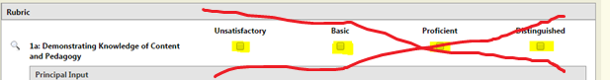

*The UI should not infer that there “could” be underlying scores at the component or observation level:*

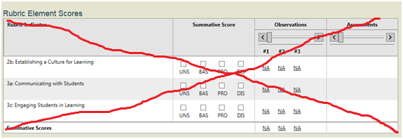

**ILLUSTRATION – 2.2**

*The Observation Report should not reference the ability to score at the domain level, component level or overall observation level:*

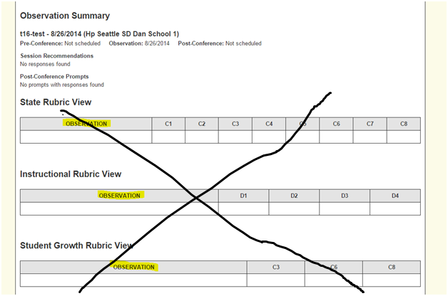

**ILLUSTRATION – 2.3; 2.4**

*When a user right clicks and selects “Hightlight and add to evidence”, only the selected text should appear on the observation or evaluation report. The actual rating (i.e., “2” or “Basic”) should never be associated with the highlighted text. Also, the user should then be prompted to add appropriate evidence to support the Claim Statement*

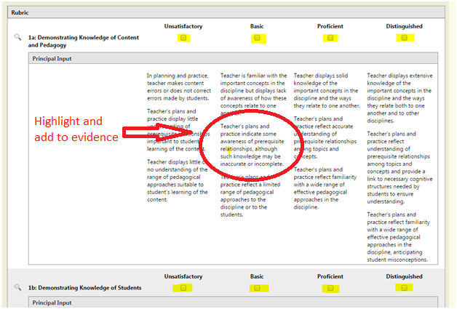

**ILLUSTRATION – 2.5 and 2.7**

Evaluators should not have the ability to score at the component level (except for Student Growth scores). If the example below did not have Student Growth scores as part of the Criteria, then the user would not be able to score any of them. (The requirement is not inferring that the components must be removed from the UI, just that an evaluator can not inadvertently score them -- the District looks to the eVal team to suggest a feasible UI design that does not require significant work effort for their team.)

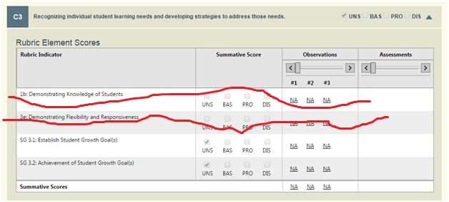

**ILLUSTRATION– 2.6**

The evaluation report should contain no inference that evaluating at the component level is possible (i.e., not columns and no empty boxes)

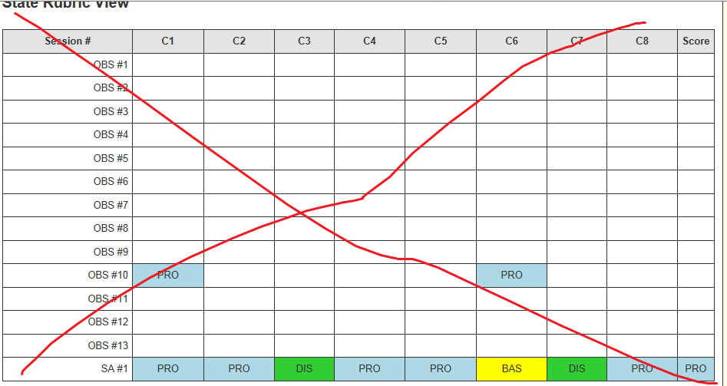

The report should have scores at the critiera level and not infer that there is the possibility of rating at the component or observation level:

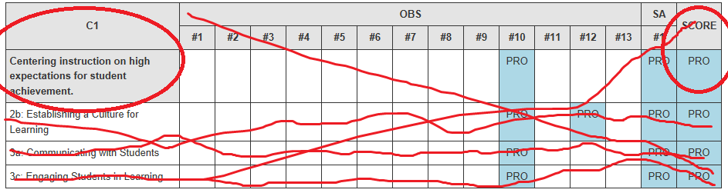

# Review and Approval

|  |  |  |  |  |
| --- | --- | --- | --- | --- |
| Team | Person | Organizational and Project Roles | Role | Date review/approval received |
| Project | Clover Codd | Exec Director Strategic Plan & Partnerships; **Project Sponsor** | Approve project deliverable | 11/5/14 |
| HR | Brent Jones | Asst Superintendent for Human Resources; Project Steering Committee representative for HR; Internal customer for many of the technology updates requested in these documents | Approve project deliverable | 11/19/14 |
| HR | Elaine Williams | Subject matter expert representing Labor Employee Relations Team | Review | 11/14/14 |
| HR | Denise Williams-Saunders | Subject matter expert representing Labor Employee Relations Team | Review | 11/14/14 |
| HR | Sue Means | Subject matter expert representing Labor Employee Relations Team | Review | 11/14/14 |
| DOTs | Nancy Petersen | Director, Enterprise Applications | Informational | 11/6/14 |
| DOTs | James Bradley | Manager, Business Applications | Informational | 11/6/14 |
| DOTs | Mabel Mah | Sr Business Analyst (SAP/HR); project systems analyst representing DOTs for design and development | Review and accept as milestone deliverable | 11/14/14 |
| eVal Dev Team | Anne Chinn | Lead eVal Developer | Review and accept as milestone deliverable | 11/7/14 |
| eVal Dev Team | Dana Anderson | eVal Supervisor/ Project Manager | Review and accept as milestone deliverable | 11/7/14 |